AI Notes Summarizer
Title:AI-Based Notes Summarization System using Transformer Models

Introduction
In today’s digital era, students and professionals deal with large amounts of textual data such as lecture notes, articles, and documents. Reading and revising long notes is time-consuming and inefficient.
To solve this problem, we developed an AI Notes Summarizer that automatically converts long notes into short, meaningful summaries using Natural Language Processing (NLP) and Transformer-based models.
This system helps users:
- Save time
- Understand key concepts quickly
- Improve productivity and learning efficiency

What is Abstractive Summarization
There are two main types of text summarization:
1️⃣ Extractive Summarization
- Selects important sentences directly from the original text
- Does not generate new sentences
2️⃣ Abstractive Summarization (Used in our project)
- Understands the meaning of the text
- Generates new sentences similar to how humans summarize
- Uses deep learning and transformer models
👉 Our project uses Abstractive Summarization, which produces more natural and human-like summaries.

Step-by-Step Method (Working of the System)
Step 1: Input Note File
- User stores text files (.txt) inside the data folder
- Example: note1.txt, note2.txt, note3.txt

Step 2: Load AI Model
- We use transformer-based summarization models such as:
  - facebook/bart-large-cnn
  - google/pegasus-xsum
- The model is loaded using the Hugging Face transformers library

Step 3: Read Original Text
- The system safely reads the selected note file
- try-except handling ensures:
  - No crash if file is missing
  - Friendly error message for the user

Step 4: Generate Summary
- The AI model generates a summary using:
  - max_length (controls summary size)
- We experimented with:
  - 30 words
  - 60 words
  - 100 words
  - 150 words

Step 5: Generate HTML Report
- The system automatically creates a professional HTML report
- Report includes:
  - Original text (blue box)
  - AI-generated summary (green box)
  - Date, model name, and author details

Step 6: View in Browser
- User opens index.html
- Clicks “View Latest Summary”
- Sees the final report in the browser
1…Home page ….
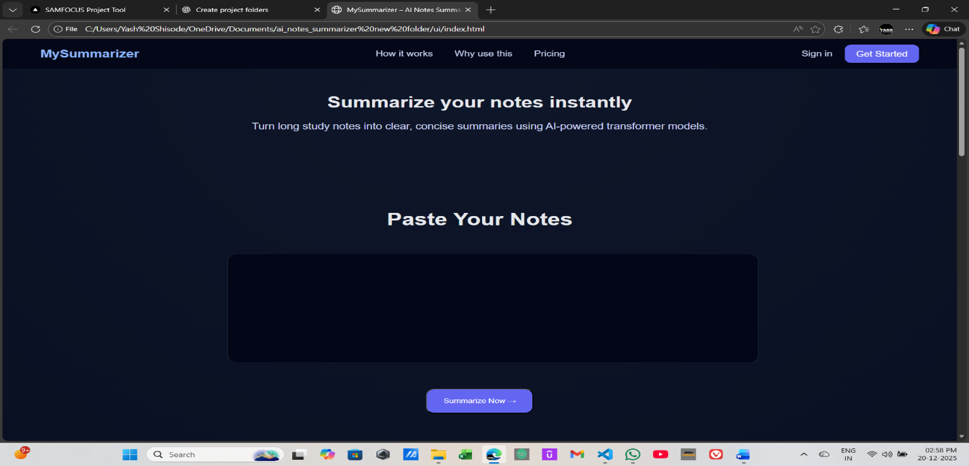
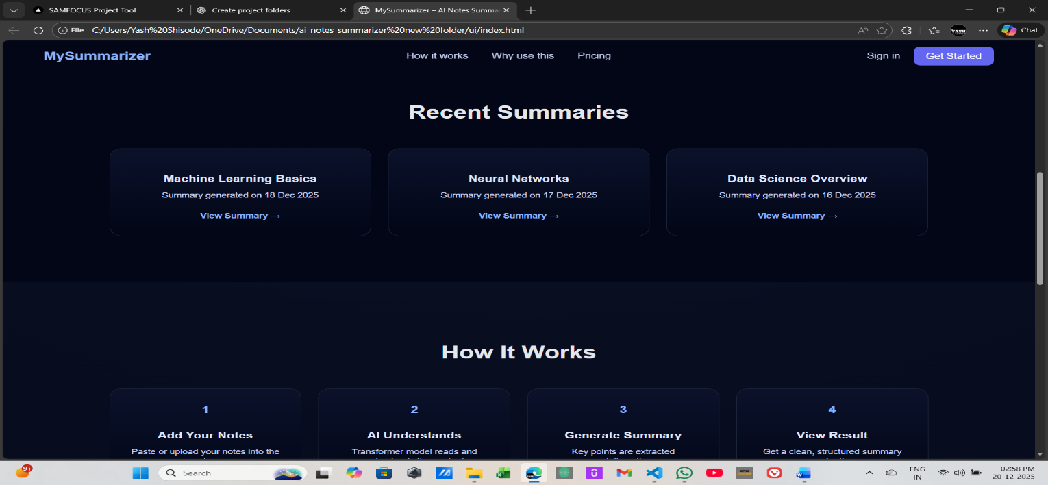
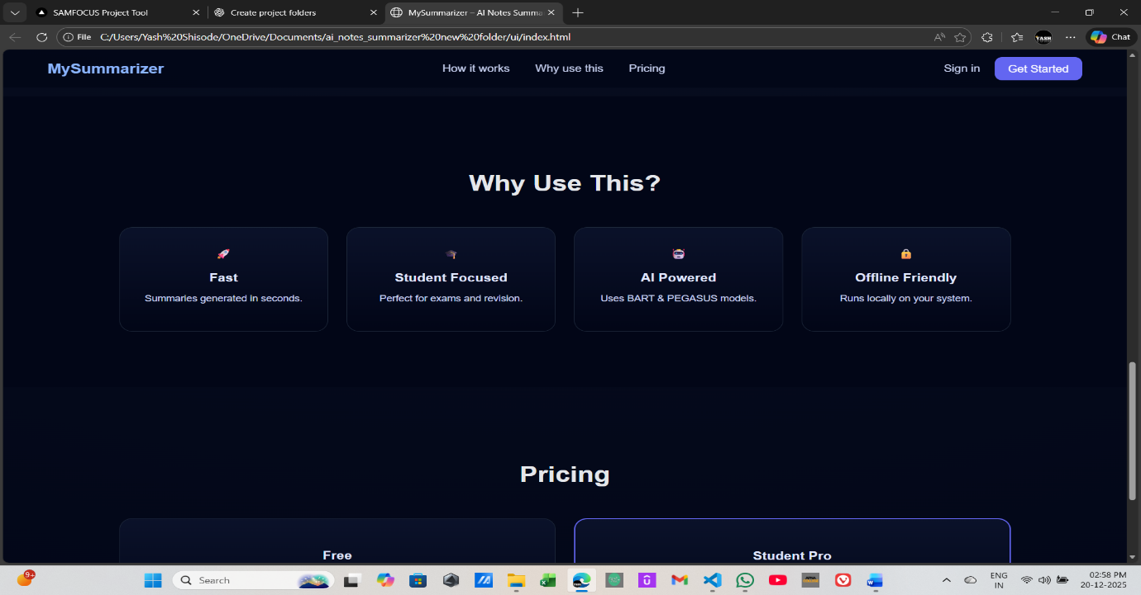
2…….Summary report page……….
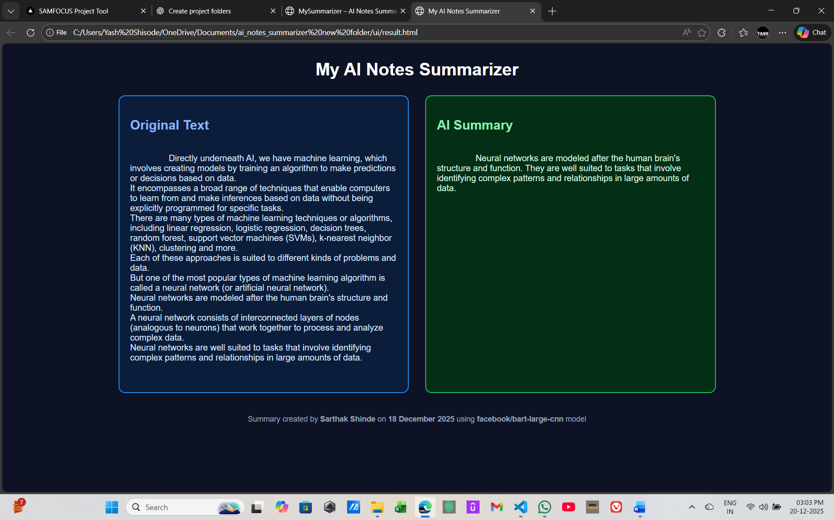
3……….Summary with max_words = 30……………..
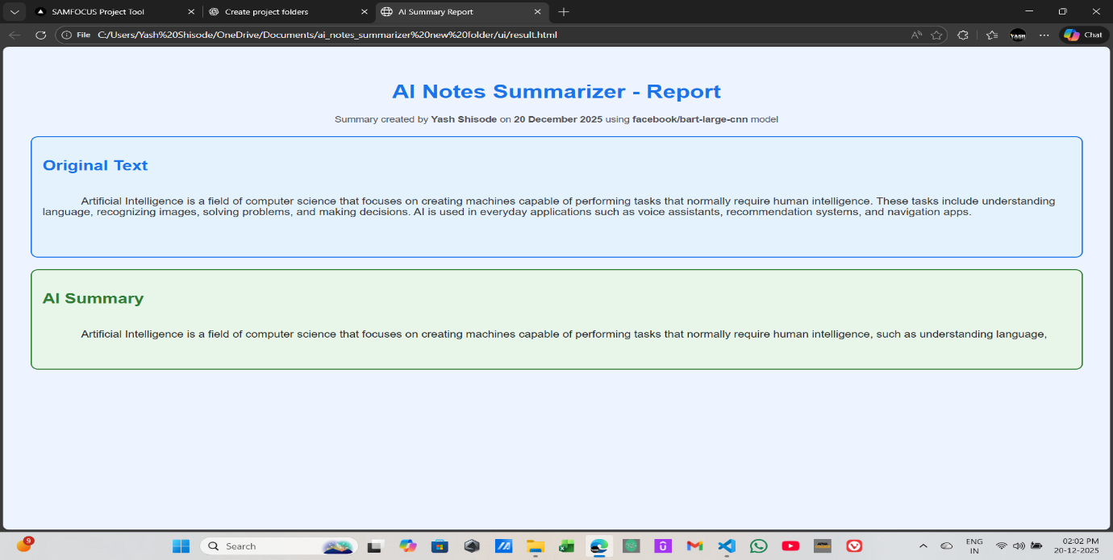
3…….Summary with max_words = 60………..
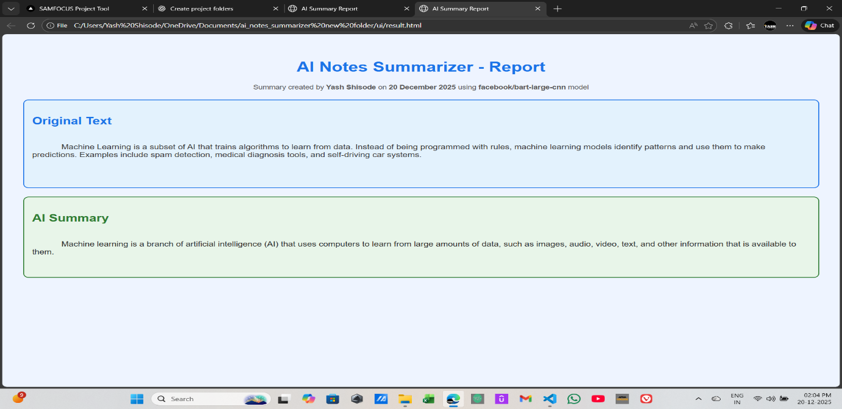
4………Summary with max_words = 100……….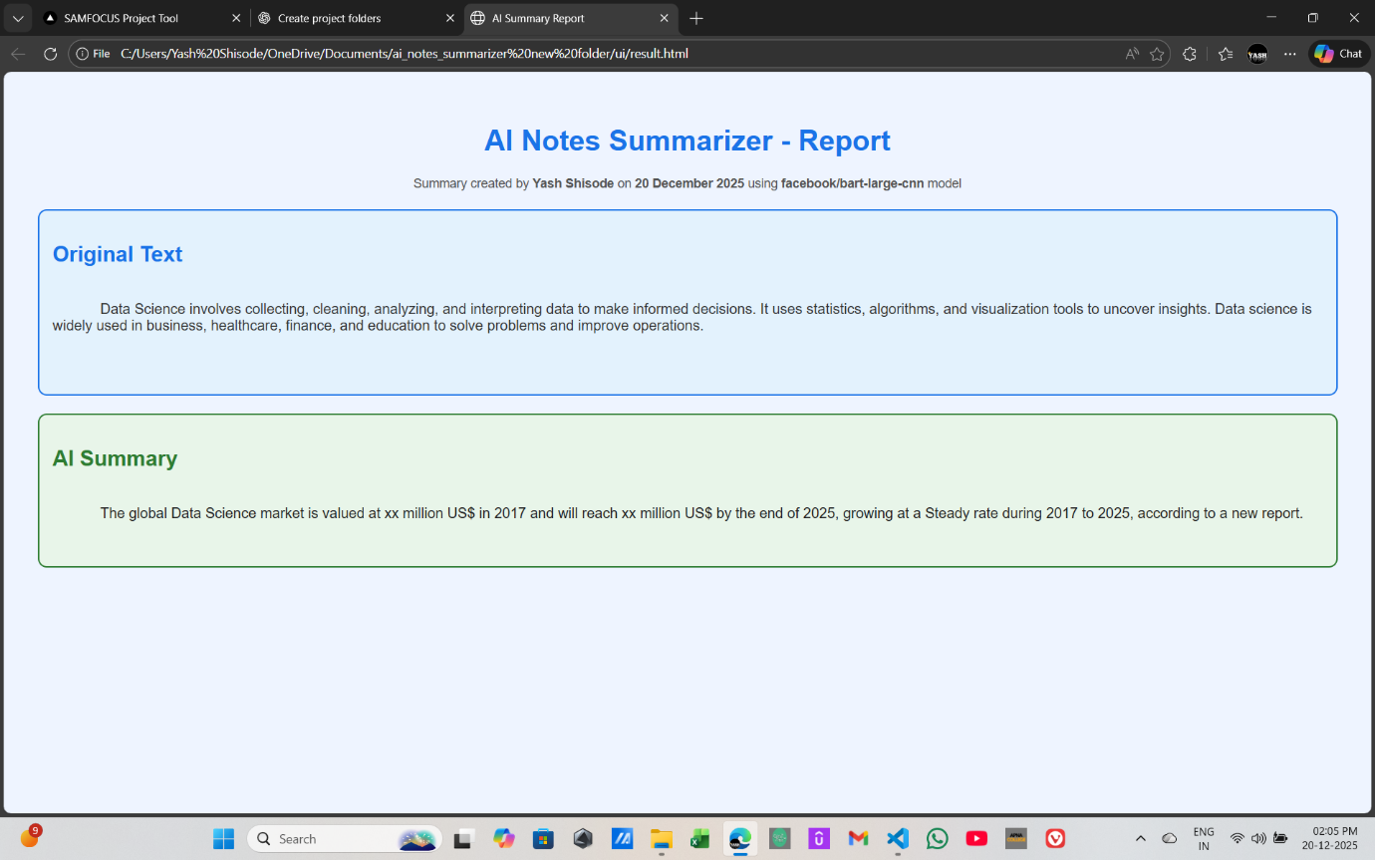
- 5…..Summary with max_words = 150
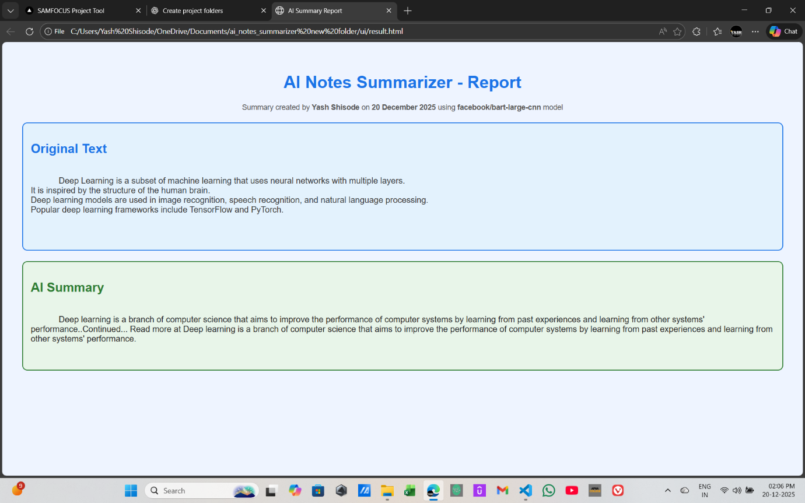

Conclusion:
The AI Notes Summarizer successfully demonstrates the use of modern NLP techniques to solve a real-world academic problem.
By using transformer models, the system produces high-quality abstractive summaries and presents them in a clean, professional frontend.
This project shows how AI can be practically applied in education to enhance learning and productivity.

What I Learned:
Through this project, I learned:
- Basics of Natural Language Processing (NLP)
- Working of Transformer-based models
- Difference between extractive and abstractive summarization
- Using Hugging Face transformers library
- Python file handling with error management
- Generating dynamic HTML reports
- Designing simple yet professional frontend interfaces
- End-to-end AI project development workflow

